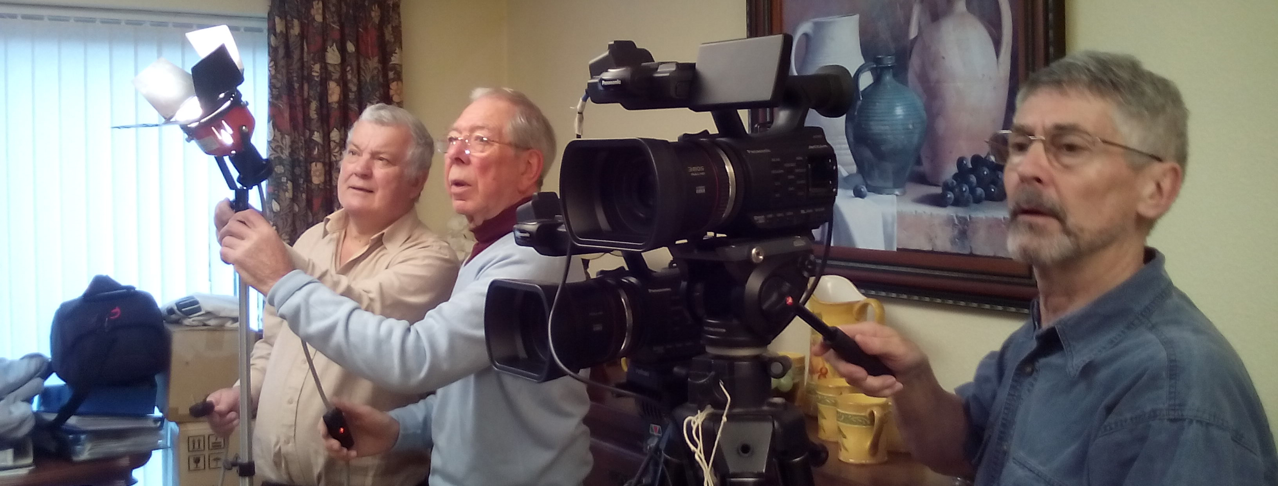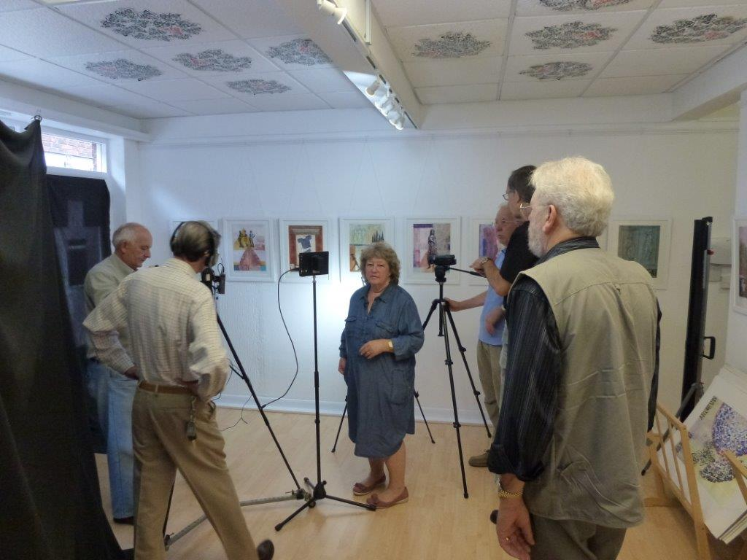

South Downs Film Makers

The Club has organised a training day for film-making on Sunday 24th April 2016. This is aimed at potential new club members, as well as existing members of the club. There will be a charge of £10 for non-members attending the course. If you subsequently join the club, £5 will be deducted from your membership fee. Existing members will pay £5 to attend.

The idea is to **‘Make a Film in a Day’** and is being planned as a whole day event starting at 10:00am at Ferring Village Hall, in Ferring, giving experience of using the club’s own cameras, lighting and sound equipment under guidance from our more experienced club members.

Filming will take place in the morning and editing in the afternoon. There will be a short lunch-break, for which attendees should bring their own packed lunch, or use the local supermarket or pub (Henty Arms).

If you are interested in joining our training day, please visit our website and complete the on-line application form.

Alternatively for further information please call 01903 504203.

www.southdownsfilmmakers.org.uk

**‘Make a Film in a Day’**